Background Information

Basal Atco Formation and Austin Chalk
The Atco Formation is located at the base of the Austin Chalk in Texas which extends from the Rio Grande River northward to San Antonio, through Dallas County and into Red River County.

Strata of the Austin Chalk, including the Atco Formation are fine-grained and consist of chalk, marl and limestone. The Atco Formation also contains marine sedimentation from the upper Cretaceous and Coniacian Stage which occurred approximately 89 million years ago. Once referred to as the “fish bed conglomerate” the formation contains elasmobranch fossils.

The Atco Formation can be correlated with the Earnst Member of the Boquillas Formation in Texas based on occurrence of Allocrioceras hazzardi and Peroniceras lepeei. The Boquillas Formation was deposited during the Late Cretaceous and is located in West Texas at Big Bend National Park.

Citation: Hamm, Shawn A. and Cicimurri, David J. 2011. Early Coniacian (Late Cretaceous) Selachian Fauna from the Basal Atco Formation, Lower Austin Group, North Central Texas. Paludicola 8(3): 107-127.
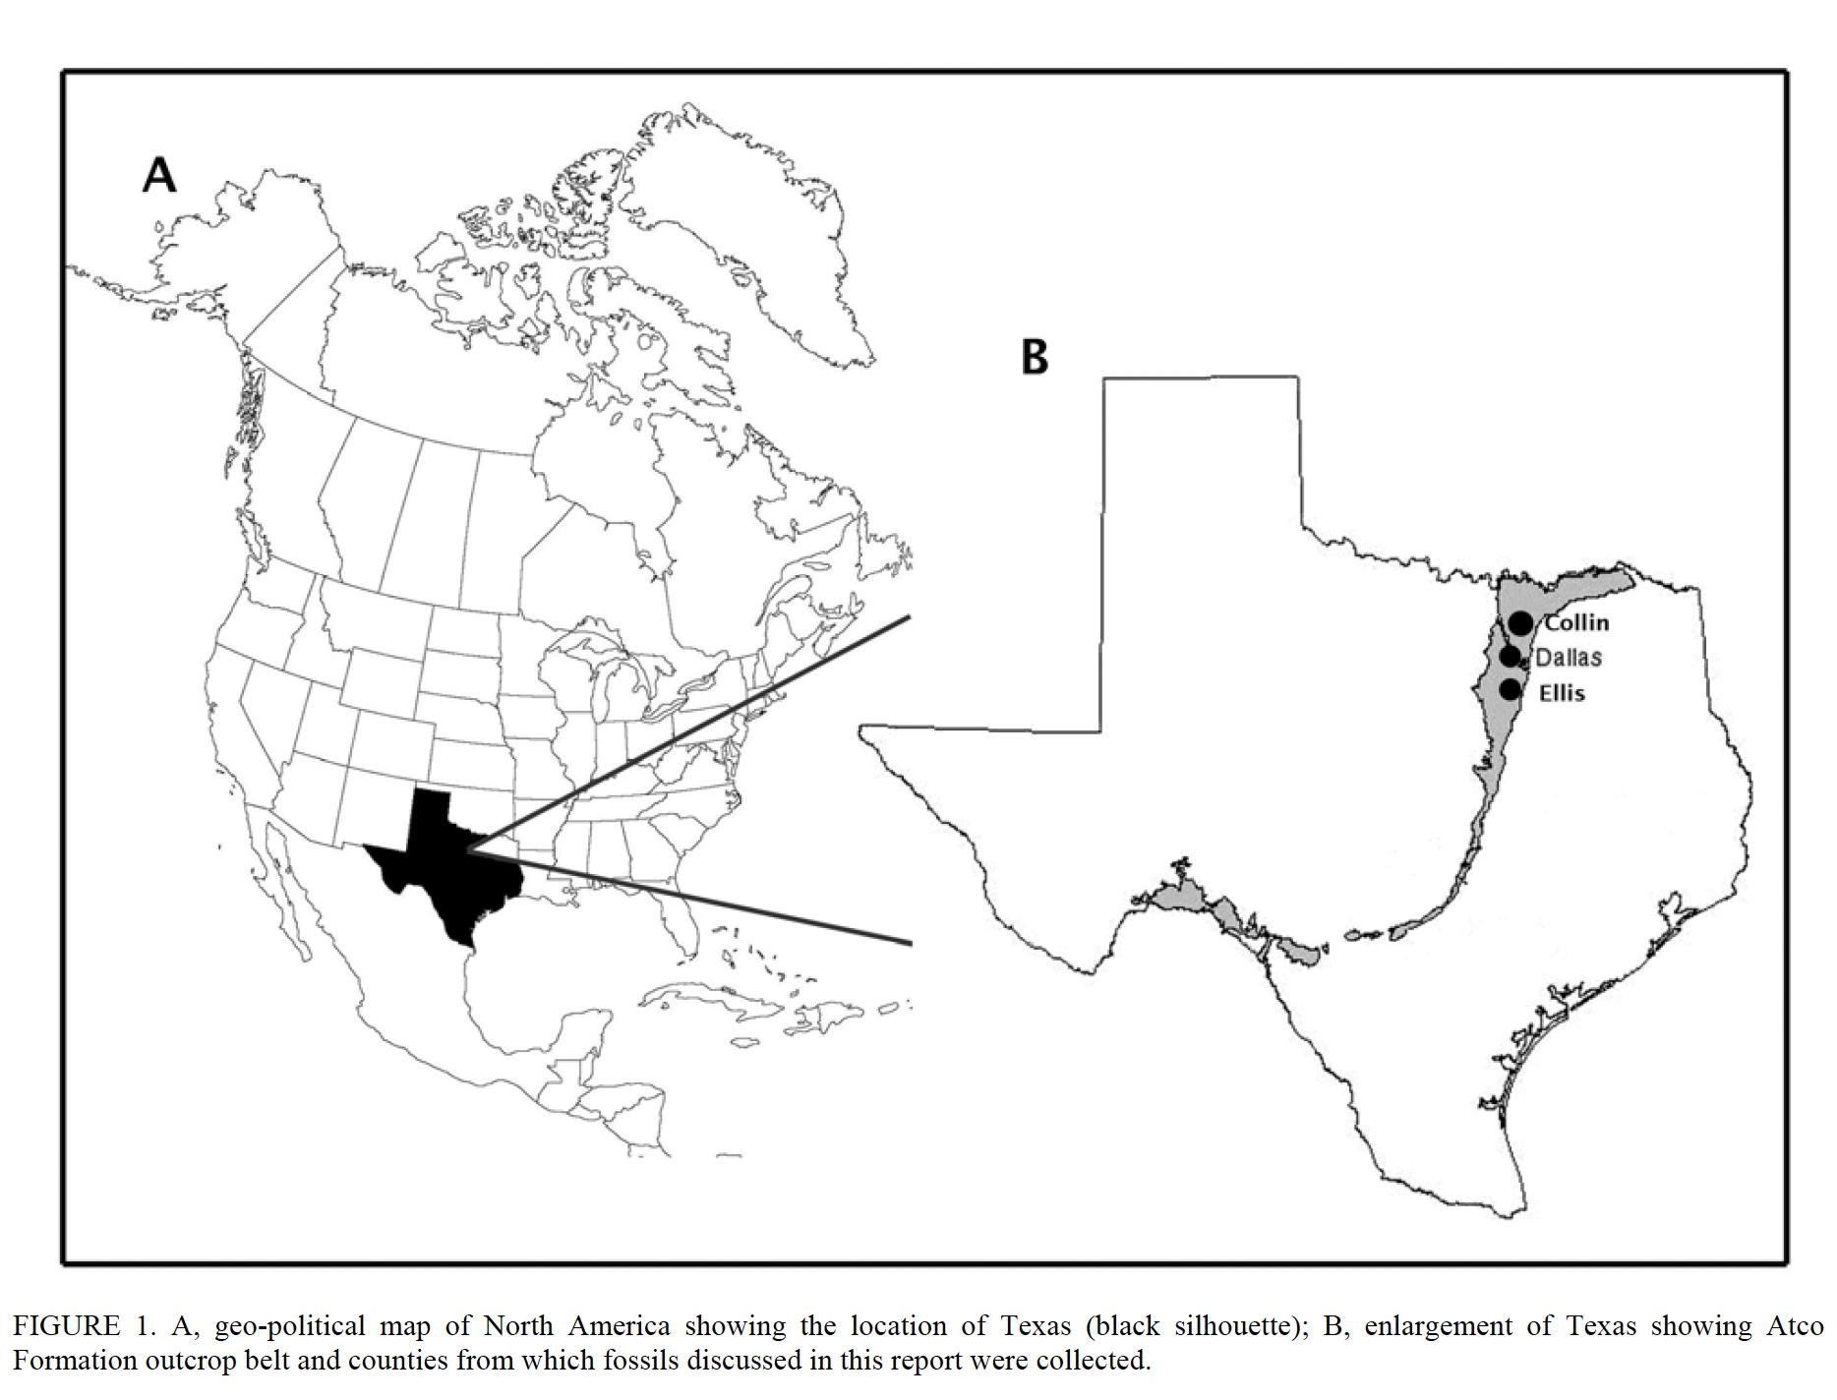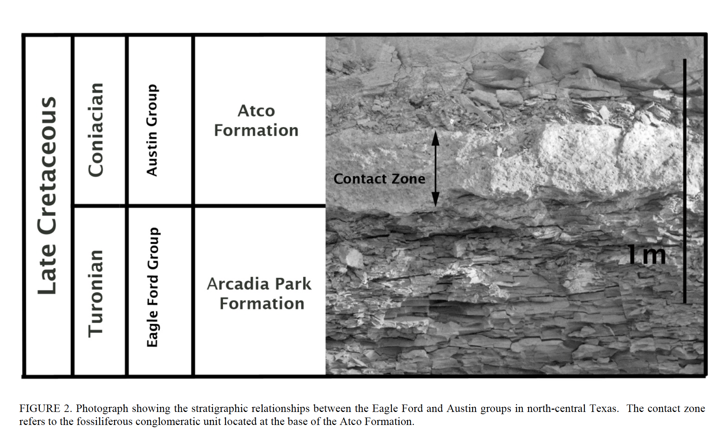

Citation: Hamm, Shawn A. and Cicimurri, David J. 2011. Early Coniacian (Late Cretaceous) Selachian Fauna from the Basal Atco Formation, Lower Austin Group, North Central Texas. Paludicola 8(3): 107-127.

