Where was the matrix collected?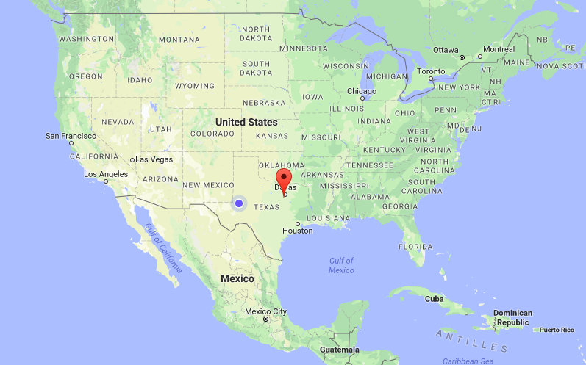Blue pin – Odessa, TX
July 15, 2017
Red Pin – Midlothian, TX
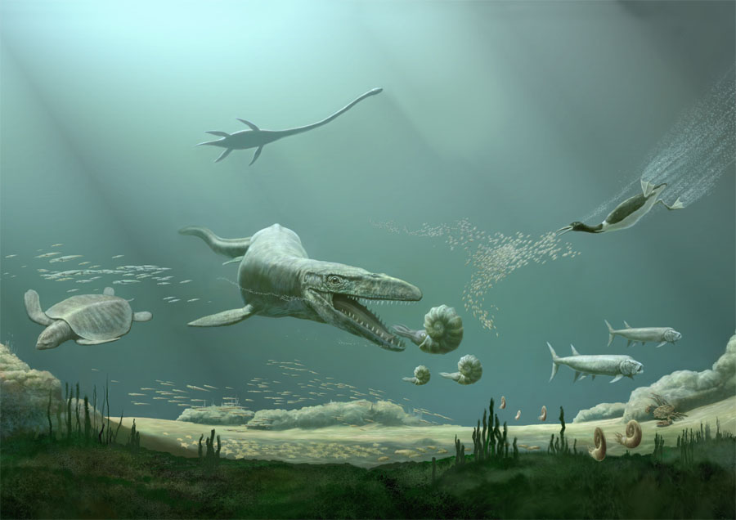
Ancient Seas of Texas
Cretaceous Epoch

Pictured:
Mosasaur, Pleisiosaur, Hesperornis, Protostega, belemnites, nautiloids, crabs, starfish and Xiphactinus

Midlothian Quarry – Present Day
